IT 511: Object Oriented Application Development
Module Nine: Collection Manager Program
ZyBooks: Programming in Java: Early Objects
Chapter 9
5/16/22

Learning Objectives

- Create data types for a functioning collection manager program
- Create and apply appropriate control structures for a functioning collection manager program
- Implement appropriate methods for a functioning collection manager program
- Construct collection and items classes for a functioning collection manager program
- Use inline comments and API documentation to document a collection manager program

Textbook Sections

Chapter 9: Methods Continued
- 9.8 Javadoc for Methods

Module Overview

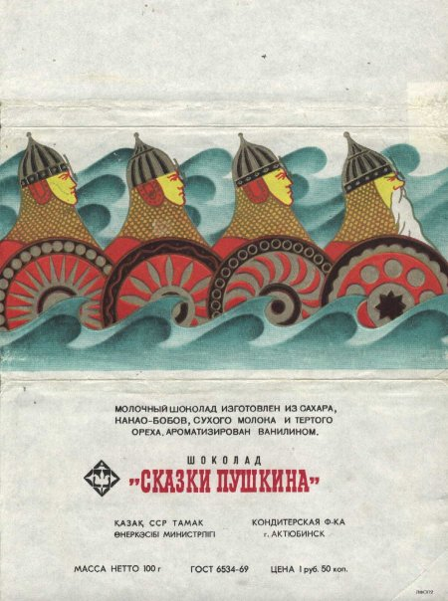
Image 9.1: Chocolate Wrapper From Kazakhstan
(Image Source: Pinterest)
This item is from a collection of chocolate wrappers from all over the world. This wrapper is from Kazakhstan. How could such a collection of wrappers be ordered?

Image 9.2: Collection of Old Radios
(Image Source: Mumfection.com)
This collection of old radios shows a variety of interesting designs. What classes or methods could be used to organize it?

According to psychoanalyst and art historian Werner Muensterberger, collecting is an “unruly passion” by which we interact and express our wonder with the richness of a world full of objects. People collect myriad types or classes of objects: race cars, shoes, soda cans, seashells, as well as the objects pictured above—chocolate wrappers from around the world and old radios. People are excited when they find a new item. Such collections can grow to the point of sprawling and can quickly lose a sense of organization. In fact, it may be hard to know how to organize a growing collection.
In your final project for this course, you are enacting a method for ordering an aspect of the world of objects: a potentially disorganized collection. Further, by constructing an object-oriented program, you are providing a type of order that others can use, enhance, and even add to. Through this work, you are entering a world of object-oriented programmers and developers who create the code on which the world is ordered and runs. Throughout the course, you have been working toward this collection program through a series of stepping stone labs and final project milestones. You have constructed data types, control structures, classes, and methods, and you are bringing them into a coherent, clean, and functional form. As you prepare your submission, this is the time to check every detail and test each part of the code; make this your best work, and be sure to meet all the project requirements and critical elements.
As you will note in reviewing the Final Project Guidelines and Rubric document, you also must add clear, thorough documentation that communicates your application programming interface (API) to other programmers. To complete this requirement, you will use a documentation generator such as Javadoc or Doxygen. The zyBooks material for this module will help you engage the use of Javadoc. Note that generating quality documentation is an essential part of the work of object-oriented programmers.

Reference
Muensterberger, W. (1994). Collecting: An unruly passion. Princeton, NJ: Princeton University Press.

